


Lab-2

Powered by
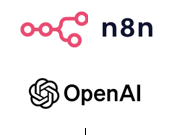

Learning Objectives
This lab will help you understand and apply a practical specialist AI Agent approach using n8n for transaction-risk assessment. You will learn how separate AI Agents can evaluate different risk areas using prepared data, business rules, guardrails, and structured outputs.

Getting familiar with the n8n workflow automation environment

- Configure Agent-2 to perform Transaction Pattern Risk Assessment.
- Configure Agent-3 to perform Regulatory Screening Risk Assessment.
- Apply the appropriate input data and dynamic business rules to each specialist AI Agent.
- Use User Prompts and System Messages to define the task, role, and behaviour of each Agent.
- Apply AI guardrails to keep the assessments aligned with supplied data and rules.
- Use Structured Output to produce consistent and reliable specialist risk assessments.
- Generate the individual risk assessment reports produced by Agent-2 and Agent-3.
- Understand how the specialist reports will be used later as inputs to the Agentic AI orchestration layer.

Task | Lab 2 Flow – Agentic AI Risk Assessment Orchestration
5 | Configure Agent-2 – Transaction Pattern Risk Assessment
6 | Configure Agent-3 – Regulatory Screening Risk Assessment

Agentic AI n8n workflow orchestration
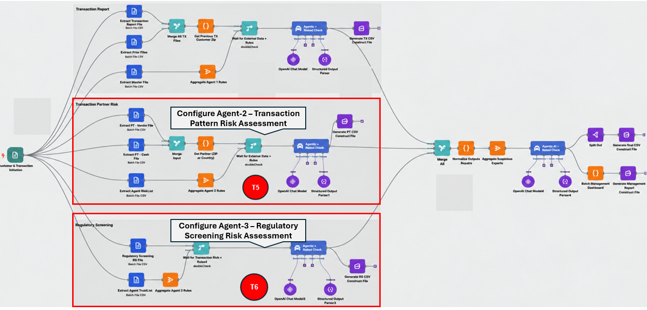

Task 5 | Create the Agent-2 Transaction Pattern Risk Workflow

Instead of rebuilding the entire branch from scratch, you will reuse the completed Agent-1 workflow. Copy the existing branch, paste it on the canvas, and then update the nodes so that the new branch processes F3 Transfer, F4 Cash Deposit, and Agent-2 Rules.

Step 1: Copy the completed Agent-1 workflow branch

- Select the complete Agent-1 branch on the canvas, starting from the Extract nodes and including the Merge node, Code node, Aggregate node, Wait node, AI Agent, OpenAI Chat Model, Structured Output Parser, and CSV output node.
- Copy and paste the selected nodes into an empty area of the workflow canvas.
- Use the copied branch as the base for creating Agent-2.

Step 2: Update the Extract from File nodes for F3, F4, and Agent-2 Rules

- Repeat the same method used in Task 2.
- Rename the copied Extract nodes to Extract F3 - Transfer, Extract F4 - Cash Deposit, and Extract Agent Rules2.
- Set the Input Binary Fields to F3, F4, and Agent_2_Rules respectively.
- Keep the Operation as Extract From CSV for all three nodes.
- Connect the three Extract nodes directly to the Customer & Transaction Validation Form Trigger.
Step 3: Update the Merge and Join nodes for F3 and F4
- Repeat the same method used in Task 3 and rename the copied Merge node to Merge F3 & F4.
- Set Mode: Append and Number of Inputs: 2.
- Connect: Extract F3 - Transfer → Input 1 and Extract F4 - Cash Deposit → Input 2.
- Rename the copied Code node to Join F3 and F4 by Customer_ID.
- Keep Mode: Run Once for All Items and Language: JavaScript.
- Update the JavaScript references so the code reads from Extract F1 - Transfer and Extract F3 - Cash Deposit.
Step 4: Update the Agent-2 Rules Aggregate node
- Rename the copied Aggregate node to Aggregate Agent-2 Rules.
- Set Aggregate: All Item Data (Into a Single List).
- Set Put Output in Field: rules.
- Set Include: All Fields and keep Include Binaries: OFF.
- Connect: Extract Agent Rules2 → Aggregate Agent-2 Rules.
Step 5: Update the Wait node for Agent-2
- Rename the copied Wait node to Wait for Transaction Data + Rules.
- Keep Mode: Choose Branch and Number of Inputs: 2.
- Set Output Type: Wait for All Inputs to Arrive.
- Set Output: Data of Specified Input and Use Data of Input: 1.
- Connect: Join F3 and F4 by Customer_ID → Input 1 and Aggregate Agent-2 Rules → Input 2.
Step 6: Configure Agent-2, the Chat Model, and Structured Output Parser
- Repeat the same method used in Task 4.
- Rename the copied AI Agent to Agent-2 - Transaction Pattern Risk.
- Update the given Agent 2 User Prompt and the system Message to use the current transaction record and the Extract Agent Rules2 node.
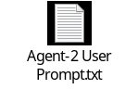 | 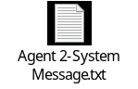
- Keep the same OpenAI Chat Model, credential, model, and Sampling Temperature 0.0.
- Keep the Structured Output Parser connected to the Agent-2 Output Parser port.
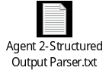

Step 7: Update the R2 CSV output node
- Rename the copied Generate R1 CSV node to Generate R2 CSV.
- Keep the operation as Convert to CSV.
- Set the file name to R2_Transaction_Pattern_Risk.csv.
- Connect the main output of Agent-2 - Transaction Pattern Risk directly to Generate R2 CSV.
Step 8: Test the workflow
- Click the  button at the bottom of the screen to run and test the complete workflow.

Task 5 Expected Output
Task 5 is complete when the copied Agent-1 branch has been successfully updated to process F3 Transfer, F4 Cash Deposit, and Agent-2 Rules, as shown in the image. The completed branch should join F3 and F4 by Customer_ID, wait for the Agent-2 rules, run Agent-2 - Transaction Pattern Risk, and generate the R2 Transaction Pattern Risk CSV report.
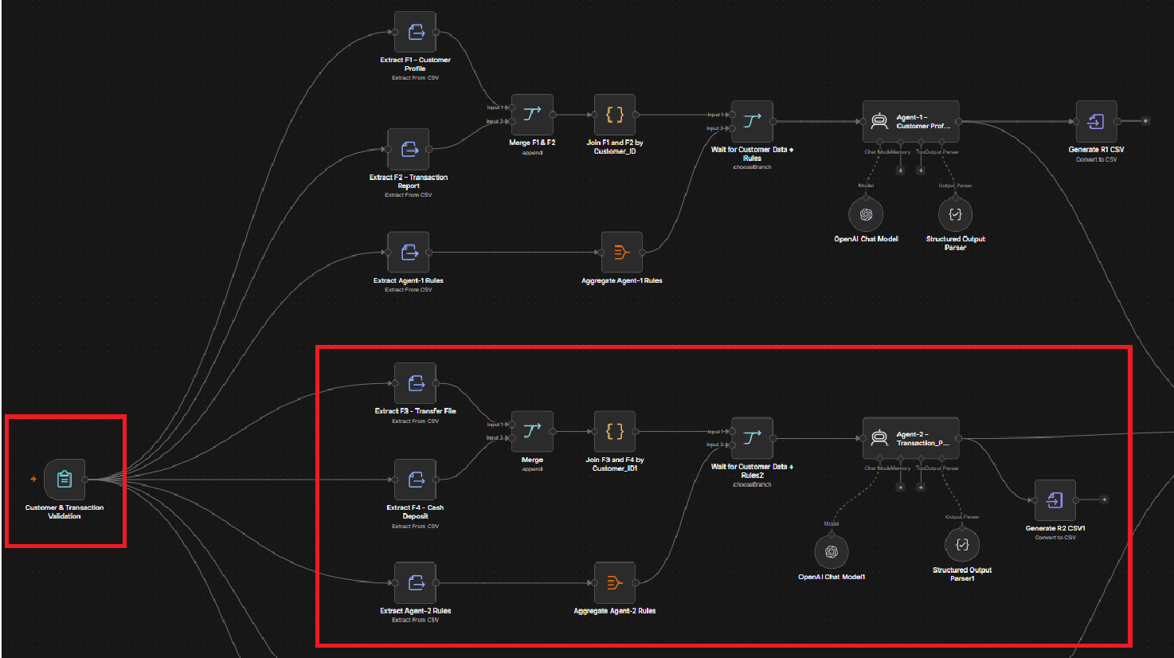


 | Please update your Answer document
Task 6 |  | Create the Agent-3 Regulatory Screening Risk Workflow
In this task, you will reuse the workflow pattern already created for Agent-1 and Agent-2, and modify it for Agent-3 Regulatory Screening Risk. Agent-3 uses the F5 Regulatory Screening file together with the Agent-3 Rules file.
Unlike Agent-1 and Agent-2, Agent-3 does not need to merge two customer data files. The F5 file already contains the regulatory screening information required for each customer.

Step 1: Copy the completed Agent-2 workflow branch
- Select the Agent-2 branch, including the Extract nodes, Aggregate node, Wait node, AI Agent, OpenAI Chat Model, Structured Output Parser, and Generate R2 CSV node.
- Copy and paste the selected branch into an empty area of the workflow canvas.
- The copied branch will now be modified for Agent-3.
Step 2: Update the Extract from File nodes for F5 and Agent-3 Rules
- Repeat the same method used in Task 2.
- Rename the customer-data Extract node to Regulatory Screening File F5.
- Set Operation: Extract From CSV.
- Set Input Binary Field: F5.
- Rename the rules Extract node to Extract Agent Rules3.
- Set Operation: Extract From CSV.
- Set Input Binary Field: Agent_3_Rules.
- Connect both Extract nodes directly to the Customer & Transaction Validation Form Trigger.
Step 3: Update the Agent-3 Rules Aggregate node
- Rename the copied Aggregate node to Regulatory Screening Agent-3 Rules.
- Set Aggregate: All Item Data (Into a Single List).
- Set Put Output in Field: rules.
- Set Include: All Fields.
- Keep Include Binaries: OFF.
- Connect: Extract Agent Rules3 → Regulatory Screening Agent-3 Rules.
Step 4: Update the Wait node for Regulatory Data and Rules
- Rename the copied Wait node to Wait for Customer Data + Rules3.
- Keep Mode: Choose Branch.
- Set Number of Inputs: 2.
- Set Output Type: Wait for All Inputs to Arrive.
- Set Output: Data of Specified Input.
- Set Use Data of Input: 1.
- Connect: Regulatory Screening File F5 → Input 1
- Connect: Regulatory Screening Agent-3 Rules → Input 2.
Step 5: Configure Agent-3, the Chat Model, and Structured Output Parser
- Repeat the same method used in Task 4.
- Rename the copied AI Agent to Agent-3 - Regulatory Screening Risk.
- Keep the OpenAI Chat Model connected to the Agent-3 Chat Model port.
- Keep the Structured Output Parser connected to the Agent-3 Output Parser port.
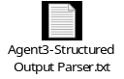
- Use the same OpenAI credentials and models, and set the Sampling Temperature to 0.0. Use the provided Agent-3 User Prompt in the Prompt (User Message) field.
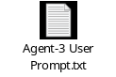
- Use the Agent-3 System Message so that all supplied regulatory rules are evaluated dynamically and the exact rule severity is preserved. Use the provided Agent-3 System Message so that all supplied regulatory rules are evaluated dynamically, and the exact rule severity is preserved.
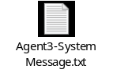
Step 6: Update the R3 CSV output node
- Rename the copied CSV output node to Generate R3 CSV.
- Keep the operation as Convert to CSV.
- Set the file name to R3_Regulatory_Screening.csv.
- Connect the main output of Agent-3 - Regulatory Screening Risk directly to Generate R3 CSV.

Task 6: Expected Output
Task 6 is complete when the Agent-3 branch processes F5 Regulatory Screening and Agent-3 Rules, waits for both inputs, evaluates each customer using Agent-3, and generates the R3_Regulatory_Screening.csv report as shown in the workflow image.

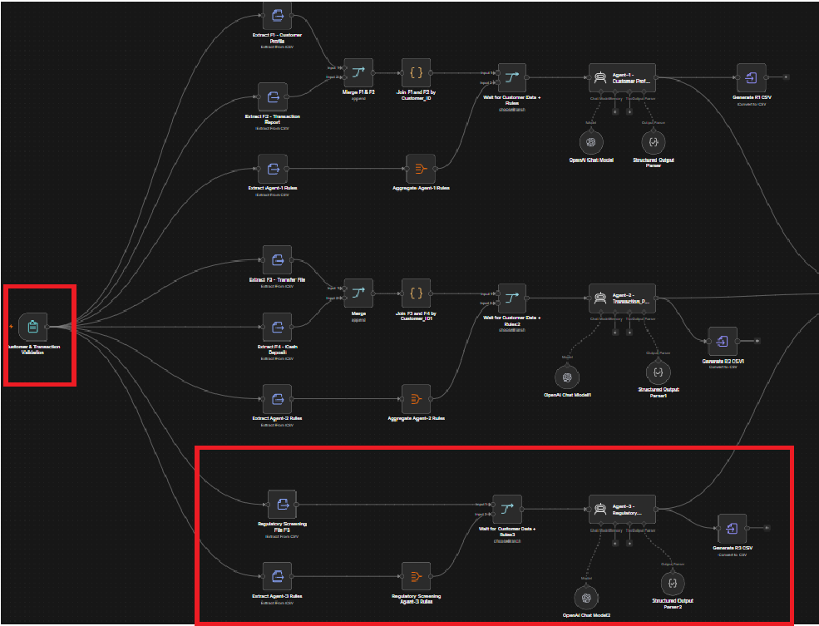


Please update your Answer document

Thank You

